National Application
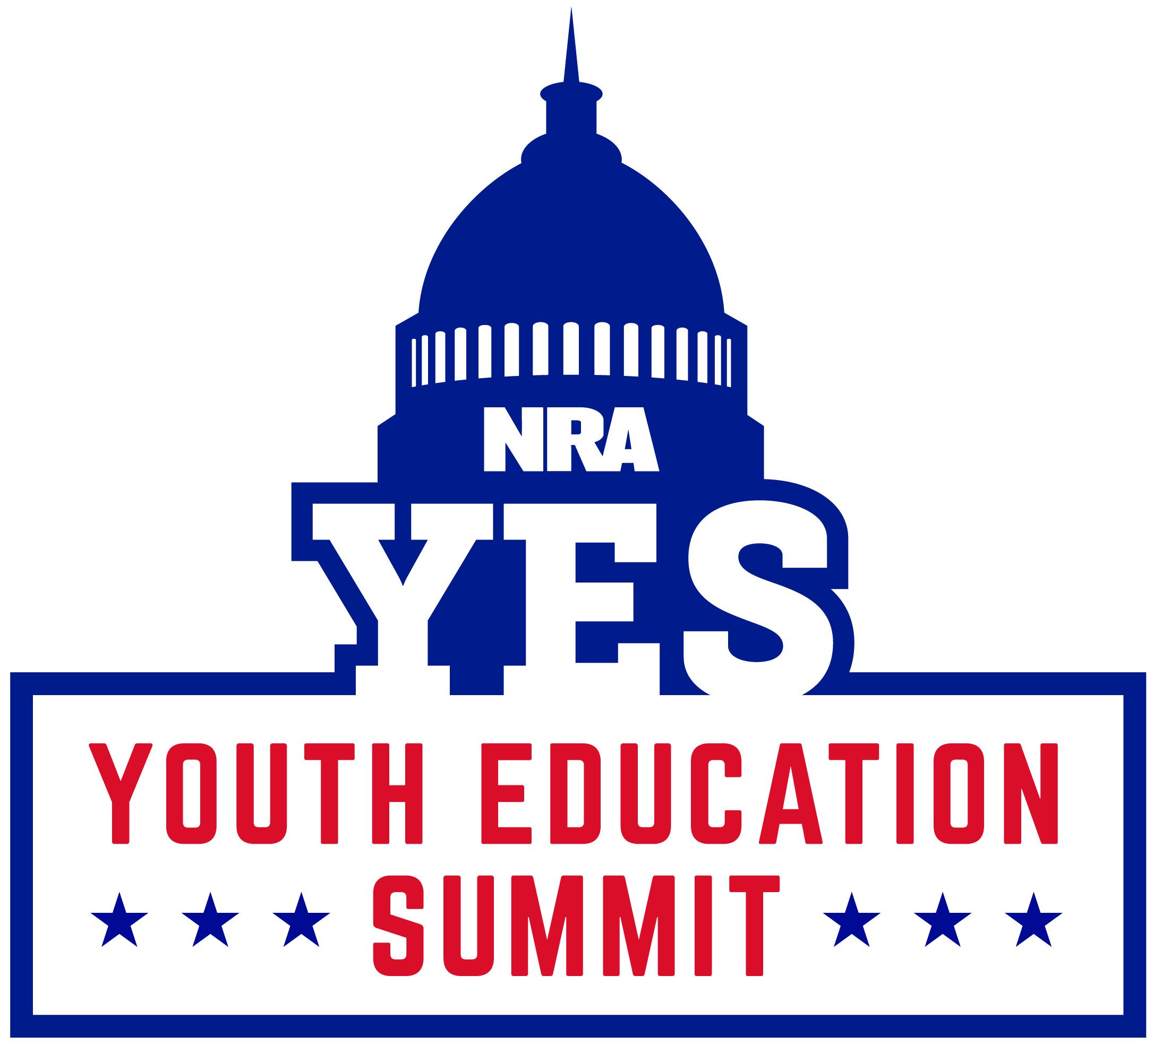

Instructions

- Carefully read the information and instructions printed in this packet.
- Include all attachments as requested.
- Securely attach all extra documents by fastening them to the packet.
- Clearly print or type your full name on the upper left corner of all pages, including attachments.
- Do not send applications in binders or stapled together. Secure documents with a paper clip
- Make sure all portions of the application are completed. Incomplete applications will not be considered.
- A physical signature under "Part VII: Signature" is required.
- Return this application as soon as possible, postmarked no later than Friday January 13th.

Return postmarked application no later than Friday January 13th to:
NRA • Field Operations Division • Abigail Klein
11250 Waples Mill Road, Fairfax, VA 22030
FAX (703) 267-3743 • yes@nrahq.org
www.friendsofnra.org/yes • PHONE (703) 267-1351

About the National Youth Education Summit (Y.E.S.)

Every summer 45-50 outstanding high school students from all over the country share a week long educational fellowship in our nation’s capital while vying for college scholarships.

The mission of the Y.E.S. program is to give students the opportunity to explore their passion for our American government, Bill of Rights and the U.S. Constitution, encourage them to become responsible citizens who participate in the democratic process and empower them to return to their communities with a proactive voice for the Second Amendment.

The week wraps up with a celebratory awards dinner where $15,000 is divvied out among those outstanding students who embody leadership as both individuals and as a collective. Students with an interest in become NRA Ambassadors for a year can submit an additional application for the Grand Scholarship which awards $25,000.

Entry into the Y.E.S. program requires submission if a completed application form, high school transcript, a three-page essay on the Second Amendment, a one page personal statement, and three letters of recommendation. These students are the best and brightest among their high school peers, actively engaging in academic, leadership, and community service.

Since its inception in 1996, more than 850 students have graduated from Y.E.S and over $500,000 in scholarships have been awarded.

2017 Y.E.S. week will be held July 24 – July 30 in the Washington D.C. area.

PART I: Applicant Information


If you are from Alaska, North Carolina, Oregon, Texas, Virginia, or West Virginia; your state has a State Youth Education Summit that you must attend first. Please visit http://bit.ly/StateYES for more information.

Name: Nickname: _________________________
Address:
City: State: Zip Code:
Telephone Number 1: ( )  Home  Work  Cell
Telephone Number 2: ( )  Home  Work  Cell
Email: Gender: Date of Birth: __________
*Please check your email inbox frequently for news and updates on your application.
Name of Parent/Guardian with whom you reside:
Special Needs or Requirements:
*The Y.E.S. week will be strenuous (a typical day will go from 6:00 am - 11:00 pm) and will include a lot of walking and bus transfers. Also, be aware that summer months are usually hot and humid in D.C., and many Y.E.S. activities will take place outdoors. Participants will be required to take part in all Y.E.S. activities.

PART II: School Information
Applicant must currently be enrolled in an accredited or equivalent high school and must currently be a sophomore or junior (no exceptions) with a minimum 3.0 GPA on a 4.0 scale, unless there are extenuating circumstances. If your school does not use a 4.0 grading scale, please calculate and convert your GPA to the equivalent on a 4.0 scale.

Name of High School:
Address:
City: State: Zip Code:
School Counselor or Teacher who will act as a reference:
Telephone Number: ( ) Current Grade:  Sophomore  Junior
Cumulative Grade Point Average (unweighted): Class Rank: of

PART III: Extracurricular, Volunteer and Shooting Sports Activities
Attach to this application a list of extracurricular, community and shooting sports activities and future building hobbies you are involved in. Please list your activities and future building hobbies in chronological order. Include school and community clubs and/or associations, leadership positions held, awards received, etc. Also include the number of years you’ve been involved in the organization and your current and past roles.

PART IV: Essay
Attach to this application an original double spaced, typed, two to three page (no longer than three pages) essay on ONE of the following topics. Correct spelling and grammar are expected. Research and credit to appropriate sources and/or bibliography must be included.

The Second Amendment in the Bill of Rights states: “A well regulated militia, being necessary to the security of a free state, the right of the people to keep and bear Arms, shall not be infringed.”

- Does the Second Amendment still hold the same meaning today as it did to our forefathers? Is it still relevant to present day American society? Why or why not?

- Where do you stand on the issue of gun control? Does the government have the right to step in and disarm the American people, even though the right to bear arms is one of the main principles this country was built on?

- What are the pros and cons of gun control? Discuss each side thoroughly.

**Note: “Extra credit” will not be given to those applicants who turn in more than one essay.
***Definition of a polished essay: A polished essay includes clear and concise sentence structure and vocabulary, unique ideas and points, and excellent grammar and spelling. This type of essay also includes points that are backed up by quotes and evidence, with proper citations; it includes smooth transitions and an intro that is direct and to-the-point, all while lacking subjective adjectives, wordiness, or "random babble."

PART V: Personal Statement

Explain why you are a good candidate for this year’s Y.E.S. Please state why you should be selected, why you are passionate about coming, and what you want to take away from this program. Simply restating your activities and leadership roles will be not be accepted as a personal statement.

Option 1: Attach to this application a statement, one paragraph to a page in length. Please type.

Option 2: Produce a PowerPoint or video, two to five minutes in length explaining why you are a good candidate for this year’s Y.E.S. You may include photos, video, or any other multimedia in your statement. Please submit PowerPoint or video on CD or USB flash drive.

PART VI: Transcripts
Attach official copies of transcripts. If you are home schooled, send notification of evaluation provided by the Board of Education, grades from an independent third-party source such as a licensed teacher, or grades from the student’s family. For all transcripts and evaluations, send your last two academic school years (one if you’re a sophomore) along with any grades from the present year. If possible, please keep official transcripts with application. Do not send separately unless required by school.

PART VII: Recommendations
Please attach three letters of recommendation from any of the following: teacher, school administrator, clergy, employer, business owner, Scout or other youth group leader, community leader, politician, or outstanding member of the community. Do not use family members. Please ask them to read the attached recommendation form before writing the letter. Please keep recommendations with application.

PART VIII: Signature
All applicants must sign and date the following to be considered.

I hereby certify that the above information is correct to the best of my knowledge and the essay is an original work written by me. I understand that knowingly fabricating any information on this application may make me ineligible to participate in the Youth Education Summit (Y.E.S.) program.

I understand that information provided on this application may be verified by the National Rifle Association of America and I authorize and request every person, firm, corporation, association, and/or agency having control of any documents, records, writings, or other information pertaining to me furnish to the NRA any and all such information the NRA believes will relate to my qualifications and/or fitness to participate in the Y.E.S. program, and to permit the NRA and any of its agents or representatives to inspect, copy, or otherwise record such information.

Signature Date

Return postmarked application no later than Friday January 13th to:
NRA • Field Operations Division • Abigail Klein • 11250 Waples Mill Road, Fairfax, VA 22030
FAX (703) 267-3743 • PHONE (703) 267-1351
STOP!

Before mailing or faxing, please be sure that you can answer Y.E.S. to the following questions:

- I have completed the Personal Information section.
- I have completed the School Information section.
- I have completed the Extracurricular Activities section.
- I have completed an essay on one of the three listed topics in the Essay section, with proper citations and it is attached to the application.
- I have completed my Personal Statement and it is attached to the application.
- I have attached the required official transcripts/notification of evaluation.
- I have attached the three required letters of recommendation.
- I have included my name on the upper left corner of all application pages.

Return postmarked application no later than Friday January 13th to:

National Rifle Association
Field Operations Division
ATTN: Abigail Klein
11250 Waples Mill Road
Fairfax, VA 22030

FAX: (703) 267-3743 – Please include cover sheet if sending application by fax.
Email: yes@nrahq.org • PHONE (703) 267-1351

www.friendsofnra.org/yes

Youth Education Summit

Recommendation Form

Youth Education Summit

Recommendation Form

Student’s Name Date:

Dear Sir or Madam,

Thank you for taking the time to complete a recommendation for the current Y.E.S. applicant. Letters of recommendation are an integral part of the entire Y.E.S. application. Therefore, your most earnest and observational thoughts on the student’s qualifications are of quite importance on this portion of the application.

We have asked that the prospective Y.E.S. student give you as much time as needed to write a letter thoroughly examining and highlighting the applicant’s strengths and weaknesses. Please note that students will not be judged on per se weaknesses; our purpose for the letters of recommendation is to give us insight and perspective on the applicant’s judgment, dependability, interpersonal skills, attitude, and initiative. We hope to gain a clearer picture of the applicant with this portion of the application, in addition his or her GPA and essay.

Please attach one letter of recommendation (a page to two pages) citing your understanding of the individual’s qualifications for Y.E.S. Specific examples of behavior and acts of ambition are extremely beneficial to the applicant. The contact information is listed below. Please do not hesitate to call if you have any questions.

Thank you,

Abigail Klein
Event Marketing and Communications Coordinator
National Rifle Association of America
11250 Waples Mill Road
Fairfax, VA 22030
yes@nrahq.org
FAX (703) 267-3743
PHONE (703) 267-1351

Letter of Recommendation: Contact Information
Please fill this section out with your contact information if it is not already notated in your letter of recommendation. This information is kept confidential. It will not be entered into a database or sold to third-party vendors.

Name:
Company:
Title:
Address:
City: State: Zip Code:
Daytime Phone: ( ) Evening Phone: ( )
Email:

Youth Education Summit

Recommendation Form

Student’s Name Date:

Dear Sir or Madam,

Thank you for taking the time to complete a recommendation for the current Y.E.S. applicant. Letters of recommendation are an integral part of the entire Y.E.S. application. Therefore, your most earnest and observational thoughts on the student’s qualifications are of quite importance on this portion of the application.

We have asked that the prospective Y.E.S. student give you as much time as needed to write a letter thoroughly examining and highlighting the applicant’s strengths and weaknesses. Please note that students will not be judged on per se weaknesses; our purpose for the letters of recommendation is to give us insight and perspective on the applicant’s judgment, dependability, interpersonal skills, attitude, and initiative. We hope to gain a clearer picture of the applicant with this portion of the application, in addition his or her GPA and essay.

Please attach one letter of recommendation (a page to two pages) citing your understanding of the individual’s qualifications for Y.E.S. Specific examples of behavior and acts of ambition are extremely beneficial to the applicant. The contact information is listed below. Please do not hesitate to call if you have any questions.

Thank you,

Abigail Klein
Event Marketing and Communications Coordinator
National Rifle Association of America
11250 Waples Mill Road
Fairfax, VA 22030
yes@nrahq.org
FAX (703) 267-3743
PHONE (703) 267-1351

Letter of Recommendation: Contact Information
Please fill this section out with your contact information if it is not already notated in your letter of recommendation. This information is kept confidential. It will not be entered into a database or sold to third-party vendors.

Name:
Company:
Title:
Address:
City: State: Zip Code:
Daytime Phone: ( ) Evening Phone: ( )
Email:

Youth Education Summit

Recommendation Form

Student’s Name Date:

Dear Sir or Madam,

Thank you for taking the time to complete a recommendation for the current Y.E.S. applicant. Letters of recommendation are an integral part of the entire Y.E.S. application. Therefore, your most earnest and observational thoughts on the student’s qualifications are of quite importance on this portion of the application.

We have asked that the prospective Y.E.S. student give you as much time as needed to write a letter thoroughly examining and highlighting the applicant’s strengths and weaknesses. Please note that students will not be judged on per se weaknesses; our purpose for the letters of recommendation is to give us insight and perspective on the applicant’s judgment, dependability, interpersonal skills, attitude, and initiative. We hope to gain a clearer picture of the applicant with this portion of the application, in addition his or her GPA and essay.

Please attach one letter of recommendation (a page to two pages) citing your understanding of the individual’s qualifications for Y.E.S. Specific examples of behavior and acts of ambition are extremely beneficial to the applicant. The contact information is listed below. Please do not hesitate to call if you have any questions.

Thank you,

Abigail Klein
Event Marketing and Communications Coordinator
National Rifle Association of America
11250 Waples Mill Road
Fairfax, VA 22030
yes@nrahq.org
FAX (703) 267-3743
PHONE (703) 267-1351

Letter of Recommendation: Contact Information
Please fill this section out with your contact information if it is not already notated in your letter of recommendation. This information is kept confidential. It will not be entered into a database or sold to third-party vendors.

Name:
Company:
Title:
Address:
City: State: Zip Code:
Daytime Phone: ( ) Evening Phone: ( )
Email:

Grading Criteria

- Cumulative GPA on a 4.0 scale. This helps to show students are dedicated, and have a good work ethic.
- Extracurricular Activities. These show a student’s leadership ability and experience, the ability to plan and balance time, varied interests, and determine if a student is active in their community.
- Second Amendment Essay. The essay displays a student’s research and writing abilities. Strong arguments, academic research, and correct grammar and citations are expected.
- Personal Statement. The personal statement should give a new glimpse into a student’s personality and their desire to come to Y.E.S. that cannot be garnered from the other parts of the application. Students should also share what it is that they hope to gain from this experience, and how it could impact them and/or others.
- References. The reference from those that know a student allow for the application committee to see a different perspective on the student, and to hear about how a student interacts with others.

